**Experiment No. - 1.2**

**Student Name: Deepak Saini UID: 20BCS4066**

**Branch: 20BCC1 Section/Group: A**

**Semester:**  **5th Date of Performance: 24/08/2022**

**Subject Name: COMPUTER NETWORKS LAB**

**Subject Code: 20CSP-342**

1. **Aim:**

Study the basic network command and Network configuration commands like ping, variations of ip config, tracert, nslookup, netstat, arp, hostname, pathping and basic networking commands.

1. **Task to be done:**

Study the basic network command and Network configuration commands like ping, variations of ip config, tracert, nslookup, netstat, arp, hostname, pathping and basic networking commands.

# 3. Requirements:

# PC.

# Command Prompt running as administrator.

# 4. Theory:

1. **Ping:** Itis used to testing a network host capacity to interact with another host.

Syntax: ping<target host’s name/IP Address>

* target: This is the destination IP address or a hostname user want to ping.
* -a: This resolves the hostname of an IP address target.
* -t: This ping command option will ping the target until you stop it by pressing Ctrl-C.
* -n count: This is used to set the number of ICMP Echo Requests to send, from 1 to 4294967295. If -n is not specified, the ping command will return 4 by default.
* -l size: This is used to set the size, in bytes, of the echo-request packet from 32 to 65,527. If the -l option is not specified, the ping command will send a 32-byte echo request.

1. **NetStat:** It is a Common TCP – IP networking command-line method present in most Windows, Linux, UNIX, and other operating systems.

* **-**a: This will display all connection and ports
* -b: Shows the executable involved in each connection or hearing port
* -e: This protocol will combine with the -sand display the ethernet statistics
* -n: This will display the address and the port number in the form of numerical
* -o: It will display the ID of each connection for the ownership process.
* -r: It will display the routing table
* -v: When used in combination with -b, the link or hearing port sequence for every executable is shown.

1. **Ip Config:** The command IP config will display basic details about the device’s IP address configuration.
2. **Hostname:** To communicate with each and other, the computer needs a unique address. A hostname can be alphabetic or alphanumeric and contain specific symbols.

* hostname -s: The output will be localhost
* hostname -i: Output the IP address for the hostname
* hostname -d: find domain system of hostname
* hostname -a: used to obtain aliases for computer

**Aliases:** They are used to replace long names or keep real name private.

1. **Tracert:** It is a command which is used to get the network packet being sent and received and the number of hops required for that packet to reach to target. This command can also be referred to as a traceroute.

Syntax: tracert [-d] [-h MaxHops] [-w TimeOut] target

* target: This is the destination, either an IP address or hostname.
* –d: This prevents Tracert from resolving IP addresses to hostnames to get faster results.
* -h MaxHops: This Tracert option specifies the maximum number of hops in the search for the target. If the MaxHops option is not specified the target has not been found by 30 hops, then the tracert command will stop looking.
* -w timeout: A timeout value must be specified while executing this ping command. It adjusts the amount of time in milliseconds.

1. **Nslookup:** The Nslookup, which stands for name server lookup command, provides name server information for the DNS i.e. the default DNS server’s name and IP Address.

Syntax: Nslookup or Nslookup [domain_name]

1. **Route:** In IP networks, routing tables are used to direct packets from one subnet to another. The Route command provides the device’s routing tables. To get this result, just type route print.
2. **ARP:**  The ARP command provides information like Address, Flags, Mask, IFace, Hardware Type, Hardware Address, etc.

the packet delivery depends ultimately on the media access control (MAC). This is where the protocol for address resolution comes into effect. You can add the remote host IP address, which is an **arp -a** command, in case you have issues to communicate with a given host.

1. **Path Ping:** The pathping command which provides a combination of the best aspects of Tracert and Ping. This command takes 300 seconds to gather statistics.

Syntax: path ping [-n] [-h] [-g <Hostlist>] [-p <Period>] [-q <NumQueries> [-w <timeout>] [-i <IPaddress>] [-4 <IPv4>] [-6 <IPv6>][<TargetName>]

* n: Prevents path ping functioning from attempting to resolve routers’ IP addresses to their names.
* -h MaxHops: This tracert option specifies the maximum number of hops in the search for the target. If the MaxHops option is not specified the target has not been found by 30 hops then the tracert command will stop looking.
* -w timeout: A timeout value must be specified while executing this ping command. It adjusts the amount of time in milliseconds.
* -ip <IPaddress>: Indicates the source address.
* target: This is the destination IP address or a hostname user want to ping.

1. **Steps for experiment/practical:**
2. Open PC and search Command Prompt in the search box.
3. Click on "Run as administrator" while selecting command prompt.

**3.** Fire all the commands on the command prompt according to the given syntax in the manual.

# 6. Result/Output

# 1. Ping:

# 

# 

**2. Netstat:**

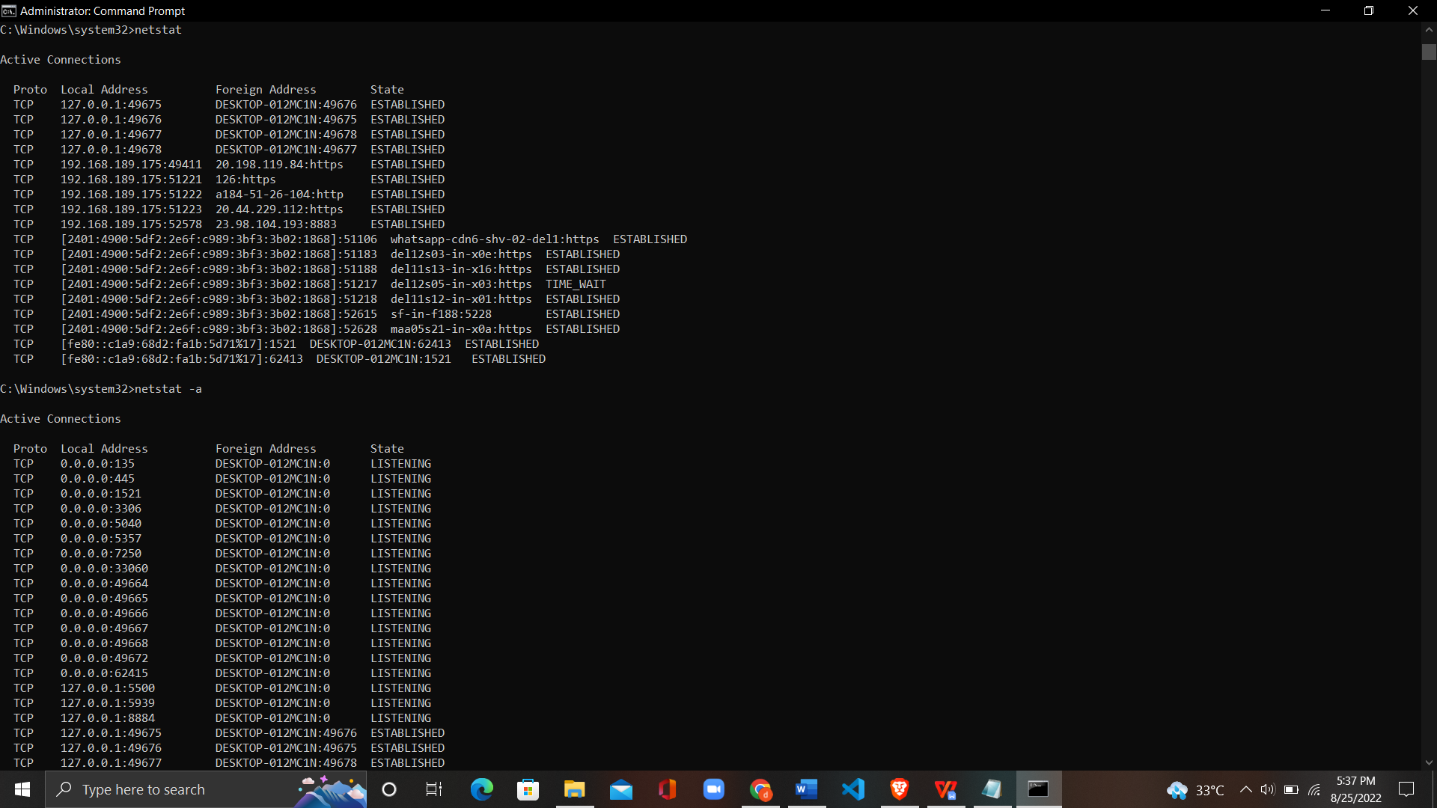

# 

# 

# 

# 

# 

# 

# 

# 3. Ipconfig:

# 

# 4. Tracert:

# 

# 

# 5. nslookup:

**6.Route print:** 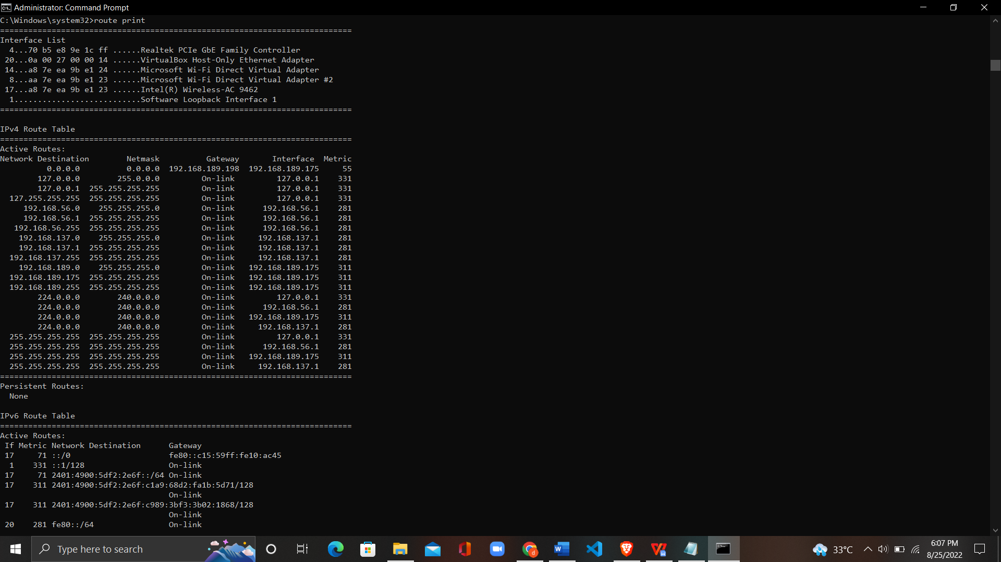

**7. Arp -a:** 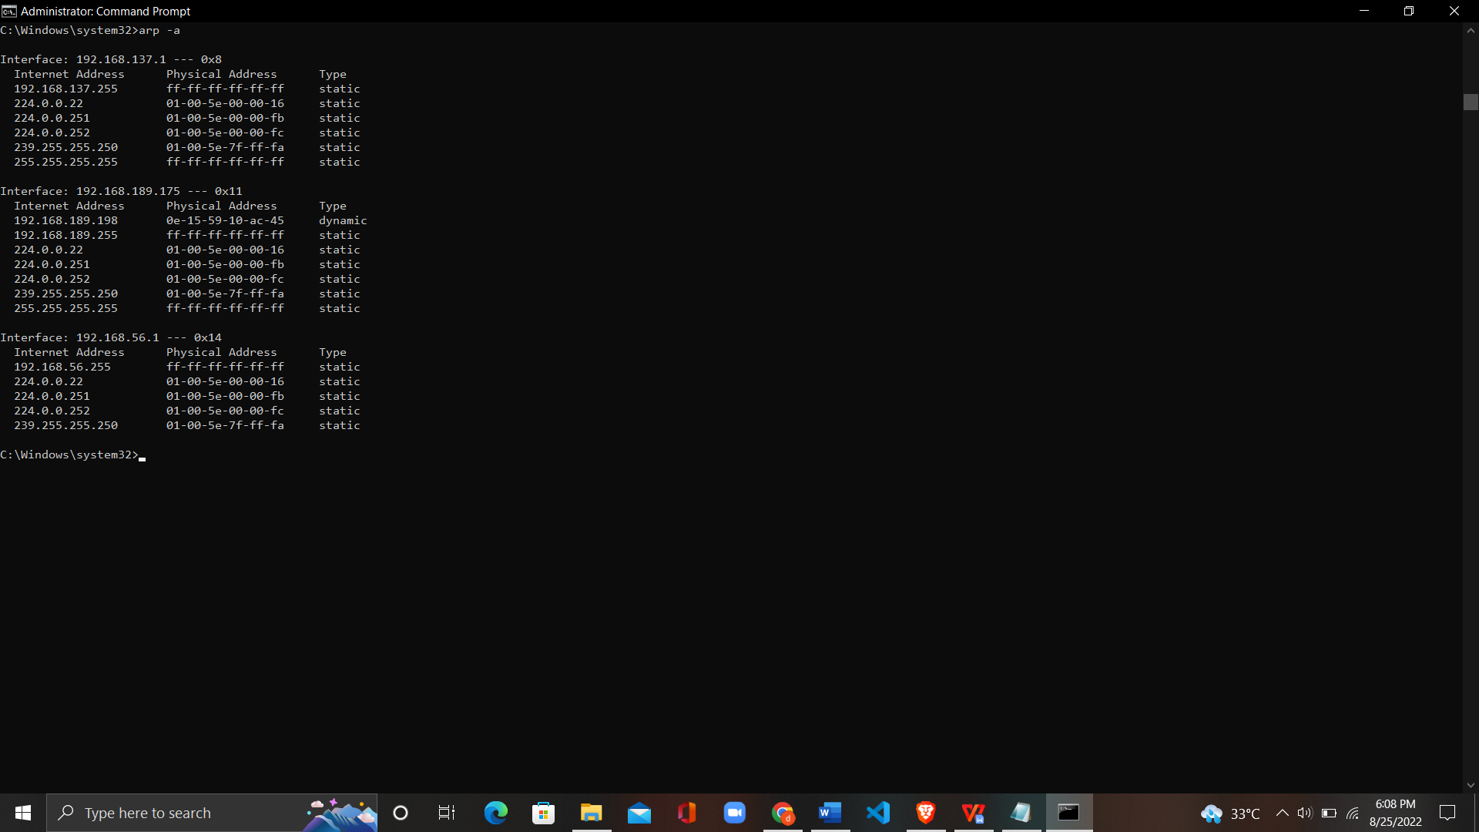

# 8. Path Ping:

# 

# Learning outcomes (What I have learnt):

# 1. Basic concepts of computer networks

2. Learn about different basic networking commands on command prompt.

3. To learn about different connection establishments techniques.

**Evaluation Grid (To be created as per the SOP and Assessment guidelines by the faculty):**

|  |  |  |  |
| --- | --- | --- | --- |
| Sr. No. | Parameters | Marks Obtained | Maximum Marks |
| 1. |  |  |  |
| 2. |  |  |  |
| 3. |  |  |  |
|  |  |  |  |